StateDiagram [frame=true framecolor=steelblue label="Exercice 1" splines=ortho] {
  state chercher as "Chercher gingembre et citron"
  state peser as "Peser gingembre"
  state ecraser as "Ecraser gingembre"
  state presser as "Presser citron"
  fork f
  join endf
  state rasemble as "Mélanger les 2"
  state eau as "Ajouter de l'eau"
  choice c_filter
  state filter as "Filtrer"
  
  initialState->chercher
  chercher -> f
  f -> presser
  f -> peser
  peser -> ecraser
  ecraser -> endf
  presser -> endf
  endf -> rasemble
  rasemble -> eau
  eau -> c_filter
  c_filter -> filter "filtrer"
  c_filter -> finalstate "else"
  filter -> finalstate
}StateDiagram [frame=true framecolor=steelblue label="Exercice 1" splines=ortho] {
  state prepa as "Preparer les ingredients"
  initialState->prepa
  prepa -> finalstate
}

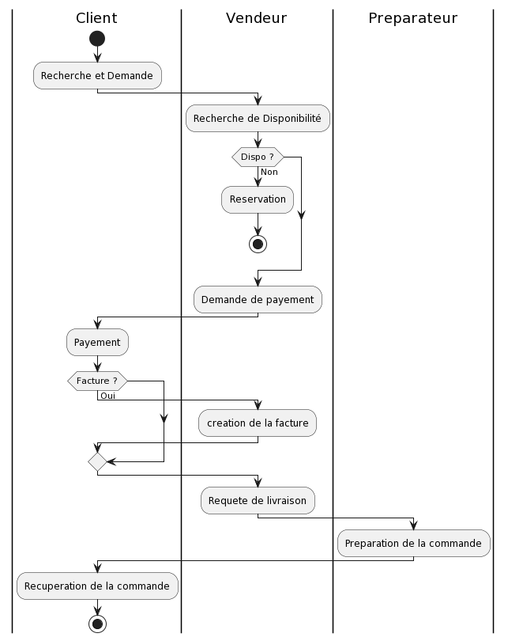

Correction:

[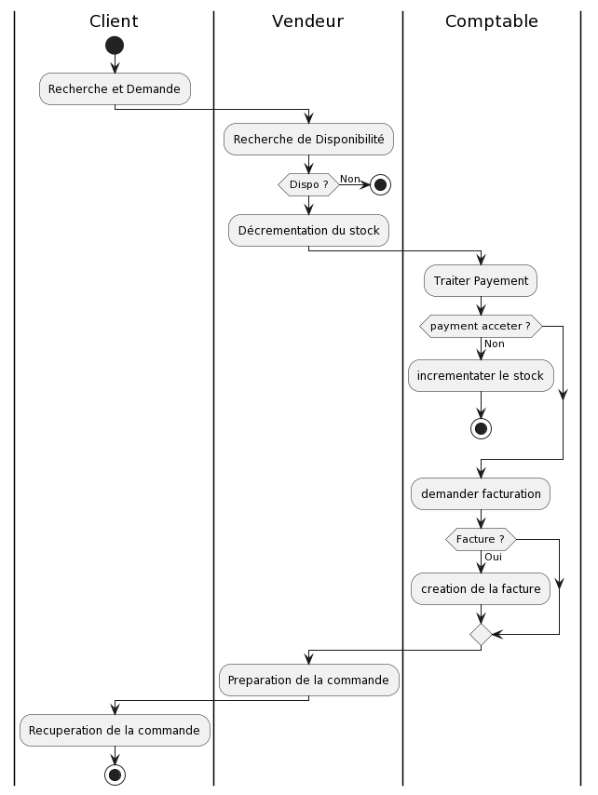](https://www.plantuml.com/plantuml/img/TP0zRiCm38LtdO9ZSWLdw12ZOniKHNTQfXiY-WDD3mPyePmZ5ojj9waxT904yL7Verv_uLHGC4AlOo3RXRqECRZ-gJJeBz-IXzJw7BA02gRU94hgfcDWEoVNAugwweFycSGMa49D4LDB1pTzaPs3JDk6bg3clkJ43GVMs_NWk8FTKeENFUYP4kpUSjexiBboSGRXpbNrxUg5ejcYSaxG3hFiB-PppB4eDe7CwLEGbGHEE2xDAxxWE5y0lQTP_MjKSNgYJLm2MSXR_tRzba275fKiGwpmrwL0lz3tWGrgoFka107lpooMbRS9voGqHxxfzJa-CdmaFKSu5FgdRHxq1m00)

Diagramme de classes Métier

[](https://www.plantuml.com/plantuml/img/AyxEp2j8B4hCLIWkgSn91P95cSabfRavN1cPAQaAkQab6VafnLp9EOd5nGfE-NdnAQdnoVcvkObvGDbghbgeJ41HVaffPWcIY5iYq9WYY1fqVKe6IWgw2ag6UdfQId2jLWfAIW00)

Exercice 4:

[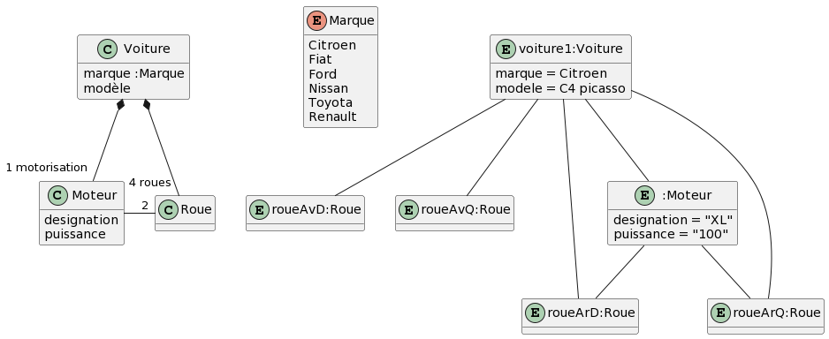](https://www.plantuml.com/plantuml/img/TL7BQiCm4BphAnOT2u6av6J8eJJqb1GSIkbLs4iZiBsf7e4G-Z_zZ_vOLx9SourxsjrXDBkQ4KTT8xJeZbHRKJNAMdWbxRn1k0g0LfaFZr3iOmq0rTzV3OhFHDwJGsy2jKQhtplbD7KydRosLdNLo3oGnojFsFaMUhsuub4xGnZUF6dbGY5JStcE0joyq8MSukQ0dVADOmt1Aawx2nWMVJXlGLcGgI_28jbloZXbnYb7peHaCY7pZv39XCoCK1iDMKLIqRiZuOy_i07vjfEvJG5QBPTot7RkO-YLXg4Omf5vF9lCH0u8cmYjuQGhTfx2TSExkyM25uKhoMWRhv4fn2bd7RzhPSnDz0nW_3uXulS-PgTFJx0Knot6BiyGonbY2I8fZz0Dilq1)

Exercice 1:

Context : Moteur

inv : puissance > 0 and puissance < 1000

Context Voiture

inv : marque = FIAT

implics motorisation . puissance < 550

Context : Voiture

inv : self.roues include self.motorisation.rouesActionnées

Exercice 3

[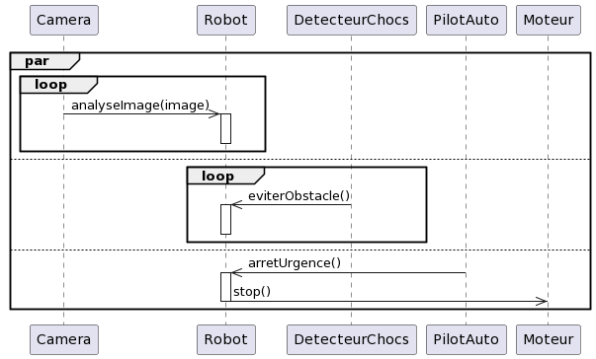](https://www.plantuml.com/plantuml/img/dP113e9034NtdA9BN7W15WQ36nT6O-81ol23amoKT0g9jnU63OQTcpPfVl_xRHcDrSOkP0DhHXH4XhaHLTn1cOwd4psb5Yk8UmwVY6l7BNA_r4DIiZC_iM7LfL63tH1zao54R1aN69nXrEejBcvPcBn1x_MSpWNaVu8UFeYTHvEVCrHXBstHkzLuvv1wMhd9agwWQ38axOwtqCgvp1_y0W00)

Exercice 4:

[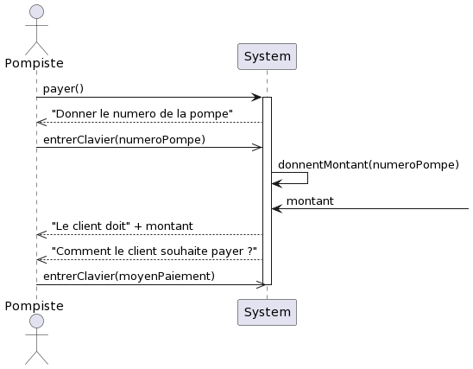](https://www.plantuml.com/plantuml/img/ZL5Dgi903DxFAK9N5ka5ogCgkbGel1E4Dc1W9bEcgT3Rczg-FX45LmDVlhzazhrYqY5uTsWq9gXZwBXNShN1t727el0x6XBStmoAQe5Aw72ajCaTDietjDd2dHyeYgfQFKl8Jb644dW26GAb22s1H-YCGTbpm7y2YIPAHuytjgHPDX4fNqAUshIJlUWbYbhlTsJuAQ24C1C-jJmJD9xDo0nPCzYkWa-AOmnXuljLsSVXYcoxF2u4kynzirw88qcDJ9DRxbnBhuVTaxJsNNS0)